Hi Alex
I connected singal port in LLD Board base on your diagram you sent me, but problem has not resolved
I checked motherboard and I got results as below:
PIN |  | Results
1 | Red | -2 V
2 | Yellow | 2 V
3 | Blue | 5 V
4 | Black | 0 V
5 | NA
6
7
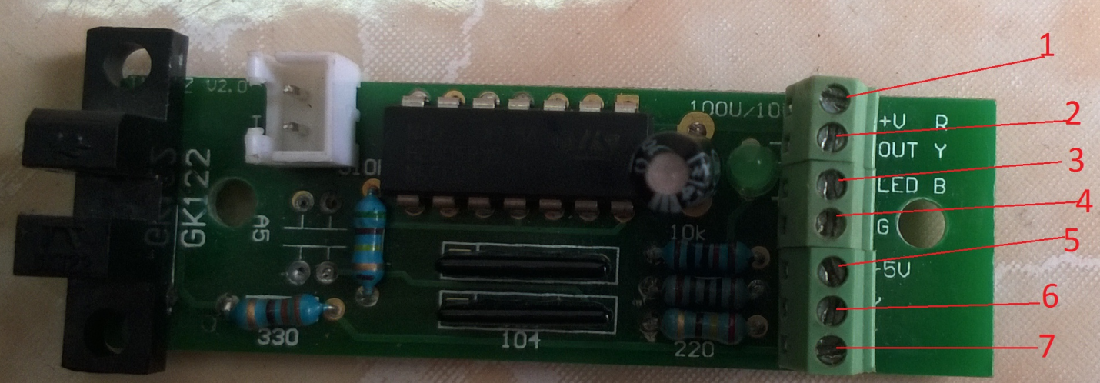
Alex help me please, If you can, you guides me how to check motherboard that supply electric for metallic circuit

