Do-it-yourself
X-Ray Phantom
in a
CD jewel case
created by Frank Weithöner
X-ray machines are complex systems. For maintenance and repair you need a lot of knowledge, the service manuals and all the expensive test equipments.
However, it is often the case that a comprehensive check is not necessary. A simple test exposure with a reliable x-ray phantom is enough. Such a simple test image shows you:
• if the collimator is adjusted correctly
• whether or not the x-ray tube delivers sufficient radiation
• potential artefacts which are caused by the developing process
A common problem is that the mirror in the collimator is maladjusted. The consequence of this is that the x-ray beam and the light beam are no longer congruent and therefore, the radiographer exposes a different detail.
In this situation a metal grid is needed. The exposure of this metal grid shows the technician how much and in which direction he has to adjust the mirror.
For a constancy check an aluminium stepwedge is needed. This is an aluminium bar where its profile decreases step by step. The result is a greyscale on the x-ray image. The x-ray machine works fine when the grey-steps are well balanced, from white to black. Usually such a stepwedge is made out of a whole aluminium block or aluminium strips of different lengths that are put together to form a stair.
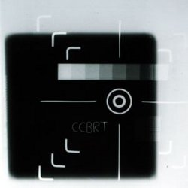 | 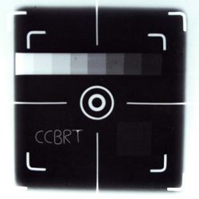
Finally, the image should be free from any artefacts, like stains and shades. This sounds ridiculous because it is so simple. However, from my experience, when a x-ray machine delivers poor images, technicians and users always immediately think of the x-ray tube and other complex units. They do not think about the simplest - the developing machine and the dark room. In developing countries, many problems arise in the dark room, for example: dirty rollers of the developing machine; old chemicals; and, believe it or not, no light-tight dark rooms.

The X-Ray Phantom in a CD jewel case
Commercial x-ray phantoms are expensive and bulky. Usually they are made out two glass panes and so they are not durable in day-to-day operation.
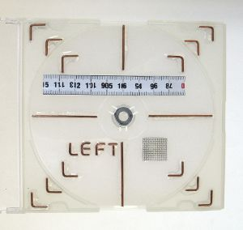 | My solution for a DIY-X-Ray Phantom is made out of a CD jewel case. It is handy, available everywhere, and durable. Also, if you take a transparent case, you can easily use my solution as a stencil by printing out the construction plan and placing it under your CD case.  In this CD case I glued copper wires - a cross for a rough overview and three squares of different sizes at a distance of 1 cm. Later, the exposure will be done by focusing on the middle square.
Furthermore, the case contains a stepwedge. For building this stepwedge I simply took an old steel tape measure and cut it into different lengths. This can be done easily with household scissors. Also cutting is simplified because measuring and marking are unnecessary. The strips are put together with super-glue.
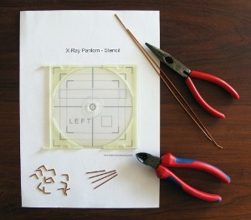 | Preparation of the wire pieces.  Take half a meter of installation wire (2.5 square is fine) and remove the insulation. Then straighten the wire by clamping one end of the wire in a bench vise, holding the other end with a pair of pliers, and pulling quickly and firmly. The wire is now perfectly straight.  Bend and cut the needed wire pieces. My corner pieces have a length of 1 cm.

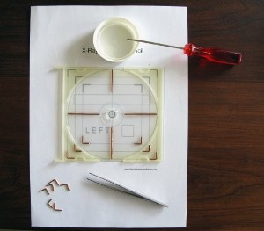 | Putting wire pieces into place.  Print out the stencil and place it under the CD jewel case.  Mix a small amount of two component adhesive, apply the glue to the case and put the wire pieces into place. Forceps or a small pair of pliers is a great help.

 | Metal grid for resolution test.  Another idea was to insert a fine mesh to check the resolution. However, either the mesh was too fine or my idea was no good. The result after exposure was not what I expected. The lines are visible, but blurred... Ideas anyone?  Anyway the tea strainer is ruined :-)

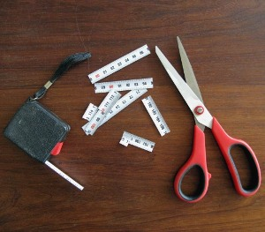 | Building the stepwedge.  I cut 9 pieces from the tape measure, starting with a length of 1 cm and ending with 9 cm. That makes a stepwedge with 10 steps (1st step no metal). The pieces are put together by using a drop of super-glue for each strip.

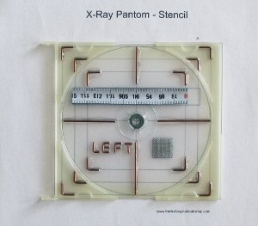 | Final works.  The stepwedge and the metal mesh are fixed with two-component-adhesive according the stencil. In addition, a washer can be fixed in the center as well.  An indicator for the right side of the image must not be missed. It can be simple letter. Or why not the name of your workshop?
The x-ray phantom is almost finished. You only have to print out the CD inlay and insert it in the CD cover. Please check if the printout is in line with the wires.
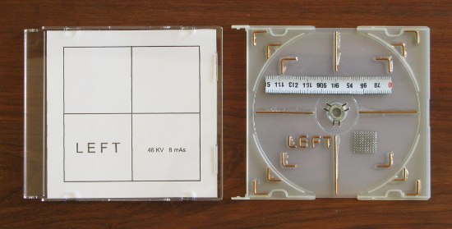

Calibration
The x-ray phantom now has to be calibrated. Use a reliable and well maintained x-ray machine and make some exposures with different settings.
The greyscale should be homogeneous. My phantom works well at 46 KV and 8 mAs.

Usage
The usage is simple. Once the right settings are found out you can use the phantom to validate other machines.
• the greyscale must be homogeneous
• the exposure must be bordered by the second square
• the rest of the image must be free of stains and shades
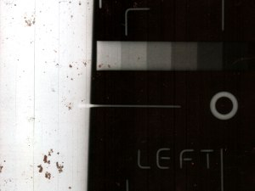 | By the way, the x-ray machine I used in our hospital is quite new. But look at this dirt on the image!  It is not always the x-ray machine which produces poor images. Think also of the film developer...

